|  |
| --- |
| **Jordan University of science and technology** |
| **Glioma tumor classification and grading for MRI brain images using Deep Convolutional Neural Network** |
| **Saad Shaqah, Omara Mustafa** |
|  |

**Abstract**

**Background:** Cancer is a large group of diseases that can occur in virtually any organ or tissue in the body when anomaly cells grow uncontrollably. It can invade neighboring parts and/or spread to other organs beyond their usual limits; it is called metastasizing which is an important cause of cancer death. New technologies, in the field of artificial intelligence and machine learning, have been used in the field of healthcare and have provided support tools for a wide range of medical fields. Convolutional neural network (CNN) is the most recent progress and state-of-the-art in the field of machine learning.

**Purpose:** The early detection of brain tumors depends mainly on the experience of the radiologist to give a good diagnosis, which makes it affected by human subjectivity, as there is a large number of researches using the convolutional neural network to classify brain tumors, but it is not mostly based on classifying the normal brain with it , For that we constructed a deep learning model that can diagnose and distinguish between normal brain, low-grade glioma and high-grade glioma from T1-weighted contrast-enhanced and Flair magnetic resonance images in high accuracy.

**Methodology:**

Our methodology is based on building a Convolutional neural network model for brain tumor classification (low-grade glioma and high-grade glioma) including classification of a normal brain, where CNN is one of the main categories to do the image recognition and image classifications, which is used to achieve good accuracy in image classification which avoids preprocessing.

**Results and Conclusion:**

The proposed network applied to the dataset consisting of 3049 cases to be classified as a low-grade glioma and high-grade glioma and a normal brain, Where the accuracy of our model reached 98.36% in test set recognition rates, this is a high percentage that we think will help clinicians in classifying brain tumors. It’s a high percentage, this model will help physicians in diagnosing and distinguish between brain tumors.

**Keywords: Deep learning, Convolutional neural network, Artificial intelligence, MRI, Medical imaging**

**Introduction**

According to World Health Organization (WHO), Cancer is the world's leading cause of death, with an estimated 9.6 million deaths in 2018. Cancer is a large group of diseases that can occur in virtually any organ or tissue in the body when anomaly cells grow uncontrollably. It can invade neighboring parts and/or spread to other organs beyond their usual limits; it is called metastasizing, which is an important cause of cancer death. The risk of cancer can be reduced by early diagnosis and by the management of cancer patients. Prevention is one of the most cost-effective long-term cancer management strategy (1,2).

Glioma refers to a type of tumor that develops in the glial cells of the brain or the spine. Gliomas consist of approximately 30% of all brain tumors and central nervous system tumors, and 80% of all malignant brain tumors(3,4). Gliomas have four grades: first and second are almost benign (non-invasive) known as low grade, while third and fourth are malignant tumors, also known as high grade Glioblastoma (GBM) (5). Based on the above information, the precise differentiation between these types of tumors is a crucial step in the clinical diagnosis process and, subsequently, in the effective assessment of patients.

Magnetic Resonance Imaging (MRI) is a medical technique that offers a detailed visualization of the internal structure of the human body, the extremities and the brain. In addition, due to its non-invasiveness, the importance of the modality of MRI in neuroscience research has been demonstrated. The special features of MRI imaging enable high spatial resolution imaging, which makes it possible to distinguish between many types of human soft tissue, including the brain, muscle fibers, abdominal organs, blood vessels and ligaments, etc. It also makes MRI more effective in the detection and characterization of soft tissue pathologies than other imaging modes (6).

MRI is the most common imaging technique used for the diagnosis and staging of tumors inside the body. However, early detection of brain tumors depends mainly on the experience of the radiologist to give a good diagnosis, which makes it affected by human subjectivity. For this purpose, new technologies, in the field of artificial intelligence and machine learning, have been used in the field of healthcare and have provided support tools for a wide range of medical fields, including imaging. In MRI image processing, different methods of machine learning are used to provide a second opinion to radiologists. The applications of machine learning in tumor classification can be divided into two different classes: the classification of brain MRI images to two main categories normal and abnormal and the grading of abnormal brain MRI images into several types of brain cancer (7–9).

Convolutional neural network CNN is the most recent progress and state-of-the-art in the field of machine learning. CNN has recently been used extensively in the classification and grading of medical imaging to diagnose diseases, since it handles raw images without the need for pre-processing or features extraction before training. CNN consists of many stacked layers: the input layer, convolution layer, RELU layer (fully connected layer), classification layer, and output layer (8).

In this paper, we constructed a deep learning model that can diagnose and distinguish between normal brain, low-grade glioma and high-grade glioma from T1-weighted contrast-enhanced and Flair magnetic resonance images. Four hidden layers were used, selecting Relu as the activation function, Adam and SGD as the optimizers used to train the network, to improve the ability of the deep learning network to classify with high accuracy. Also, Batch Normalization and drop-out methods have been implemented to improve network performance.The main contribution of our work is the inclusion of the normal class to the output of the model in addition to the classification of glioma tumors.

**Related work**

Since 2012, the Center for Biomedical Image Computing & Analytics, at Pennsylvania University, has been organizing an online competition, the Multimodal Brain Tumor Segmentation Challenge (BRATS)(10). Khan et al.(11) proposed a deep CNN model algorithm for the classification of multimodal brain tumors to improve the diagnosis by reducing the number of errors that may occur with conventional human eye diagnosis on MRI images. Deep learning feature extraction occurs through transfer learning, two pre-trained convolutional neural networks namely, VGG16 and VGG19, were utilized for feature extraction. The proposed method was tested on the BraTS data and demonstrated an accuracy of 97.8%, 96.9%, 92.5% for BraTS2015, BraTS2017, and BraTs2018, respectively. In addition to improving the accuracy of the classification, the feature selection process was effective in reducing the computational time. Alqudah et al.(8) proposed a model to investigate the classification of three types of tumors (meningioma, glioma, and pituitary tumor with T1-whighted contrast-enhanced MRI images) from an imbalanced CNN database. The results show an overall performance with an accuracy of 99% for the uncropped lesions with 98.52% sensitivity, while the accuracy and sensitivity for the cropped lesions are 98.93% and 98.18% respectively, as well as good results were obtained with segmented lesion images with 97.62% for accuracy and 97.40% sensitivity. Badža et al. (9) presented a new CNN model for classification of three brain tumor types: meningioma, glioma, and pituitary tumor from T1-weighted contrast-enhanced MRI images, and one of the 10-fold cross-validation procedure was employed to analyze the generalization capabilities of the network and the improvement was tested by using an augmented image database and the accuracy was 96.56%.

Similarly, in order to classify glioma tumors into low-grade and high-grade Mzoughi et al. (12) proposed an efficient and fully automatic deep multi-scale three-dimensional convolutional neural network (3D CNN) using the whole volumetric of T1-contrasted MRI sequences. Based on a deep network and a 3D convolutional layer, via small kernels, the architecture has potential to combine local and global contextual information together with reduced weights. Then the accuracy of using the validation dataset was 96.49%.

Wu et al. (13) proposed a classifier consisting of a deep convolutional neural network fusion with support vector machine (SVM) algorithm. Which improve the brain tumor segmentation performance applied on MRI images with the three metrics (Dice Similarity Coefficient (DSC), sensitivity and specificity) 3.5 %, 2.6%, and 3.2% higher compared to the results of SVM alone and 1.6 %, 0.9% and 2.4% higher compared to CNN, respectively. on the same hand, Seetha et al.(14) suggested an automated system for grading detection of brain tumor. This system includes segmentation using Fuzzy C-Means (FCM) for brain segmentation, texture and shape features that were extracted from the segmented brain regions were fed into SVM and deep neural network (DNN) classifiers. According to the results of the research, the system achieved a 97.5% accuracy.

In addition classification has been carried out on small image databases (15,16). Mohsen et al. (15) have used 66 images to classify four different types of brain tumors (tumor-free, sarcoma, glioblastoma and metastasis). With deep neural network, and they have obtained high accuracy 96.97%.

**Material**

This paper built on the deep learning platform based on the CNN model and to train it on the MRI brain images. We used the Cancer Imaging Archive Website (CIA) and Kaggle website to find data we want to use in the project, which is an online community of data scientists and machine learning practitioners. Cancer Imaging Archive helped us to find and publish data sets for Low and High Glioma brain images and the Kaggle website to find Normal brain images for our project and explore and build models in a web-based data-science environment.

Our data will consist of three labels: high glioma dataset which contain 871 images, low glioma dataset consisting of 688 images, and normal brain dataset which consists of 1490 images.

The proposed approach includes essentially the following steps:

1. Data preprocessing: Unify the formatting of the images, background removal, normalize, and resize the images to optimize the required memory.

2. CNN architecture design and optimization through tuning the hyperparameters, such as the number of convolution layers, pooling layers, and fully connected layers (FCLs) have been settled.

3. Model training: Training the proposed model on enhanced and processed MR images. Figure (1) shows our model Architecture

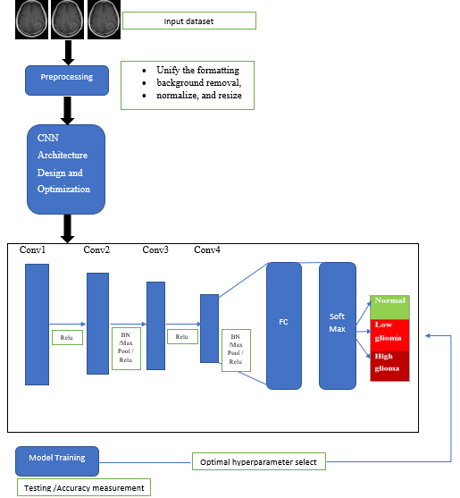

Figure (1): Model Architecture

**Methodology**

**Data preprocessing**

In this work, our preprocessing consists of 3 steps as illustrated in Fig. where Data preprocessing is one of the important stages in the deep learning process, as it helps to increase the efficiency and accuracy of the results of the deep learning algorithm and reduce the cost of complex calculations in the model.

Firstly, the format of the image files differs due to the different sources of the image download sites, as the Low and High Glioma images dataset have (Dicom) extension and normal brain images from the Kaggle have Jpg format, so it was necessary to unify the formatting of the images in order to be able to enter them to the model, so we converted all images with the extension Dicom and Jpg to jpeg format using Dicom Converter software.

In the second step, background removal was applied, which had to be removed to increase accuracy, remove noise, reduce the volume by cropping the brain from the background of the image that contains blank spaces cause slowdowns in the model and reduce accuracy using the OpenCV-Python library. Four steps were made: Step 1. Get the original image, Step 2. Find the biggest contour, Step 3. Find the extreme points, Step 4. Crop the image. The figure shows the steps of cropping the image. Figure (2) show steps for background removal

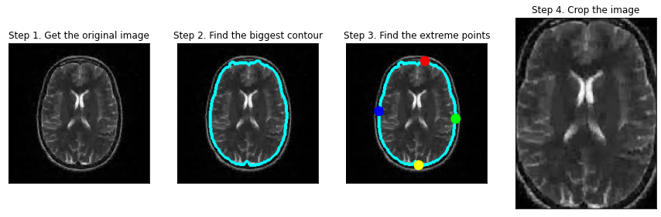

Figure (2) :Steps for background removal

Finally, all images were normalized/resize to 224 * 224 to be ready for the extraction stage of the feature. Normalization is important to avoid differences in the size or volume of the skull or brain between frames that may arise. Figure (3) shows the MRI image after normalizing.

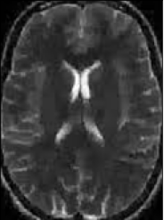

Figure (3): Brain MRI image after normalization

**CNN Architecture Design and Optimization**

Network architecture

The proposed Neural network architecture is built on four convolution layers to increase mathematical operations and accuracy for accurate brain tumors classification, where neural networks architecture contains a set of layers, an input layer, hidden layers and an output layer, each layer is connected to the next layer. The input layer contains the brain MRI images, where the convolution layer applies 64 filters with size (3*3) to the entire input image to extract features by counting the number of pixels in which the filter matches a subset of the input image, then the filter moves in steps called ” strides ”throughout the input image to cover all image regions, to create a feature map in the hidden layer, which represents and summarize the features that were recorded from the filters, where the dimensions of the hidden layer can be calculated by the equation:

The dimension of the hidden layer = (N-F)/S+1)

Where N is dimensional of the input image, F is the size of the filter that applied on the input image, S is the step (stride)which the network will take into the input image.

Activation function

The activation function considered responsible for the nonlinearity which transforms the data by applying it on the output of the filter to create the feature map, the activation functions commonly used in CNN are Relu, Absval, and Tanh, The rectifier linear unit (ReLU) is deployed as an activation function in the proposed model, We adopt “ReLU” to achieve better performance considering its ability to faster train deep CNN alternately to classical “hyperbolic tangent” or “sigmoid" functions. Where Relu represents x is the input value, and Relu function is a multi-defined function, where if x is greater than 0, the output keeps the original value, otherwise, the result is 0, The expression as follows:

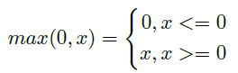

Pooling

Pooling is a down-sampling strategy on CNN, which is a down-sampling strategy on CNN Which will slide over the feature map to create a combined feature map there are two conventional forms for pooling such as max-pooling and average pooling. Max-pooling has been used, in this model, we defined a 2 x 2 pool size, this step is important in reducing the size of our feature map, making the model less complex and computationally since it extracts the most relevant features for classification like tumor edges.

Fully Connected Layer

Then we added a fully connected layer, which consists of an input layer (flatness) comes as it takes the outputs of the previous layers, and” flattens” it and converts it into a single vector that can be the input for the next stage. The first fully connected layer takes input from feature analysis and applies weights to predict the correct label. The fully connected output layer gives the final decision for each label. We applied the SoftMax activation function which normalizes the output of a network to a probability distribution over predicted output classes to complete the process of detecting and classifying between Low glioma, High glioma, and normal brain.

Optimization

The Adam optimizer has been used to learn our network weights, which works on the method of computing adaptive learning rates for each parameter at every iteration algorithm to reach the correct weights leading to the correct prediction of the image.

**Model Training**

This step where the model calculates the error function that our network takes into account before making predictions to optimize the weights and the loss function to evaluate the model, where the model applies backpropagation (BP) The BP, which is modified weights of multilayer neural networks by Adam optimizer algorithm to reach the correct weights leading to the correct prediction of the image. The loss function, which will be categorical_crossentropy, this function is used to compare the predictions’ distribution with the true one according to Eq. Where we are trying to predict is a categorical class (Low glioma, High glioma, and normal brain).

**Experimental Result Discussion and Evaluation**

In this research, 3049 cases of brain MRI images were used, classified as Normal (1490), low glioma (688), and high glioma images (871). 2439 images were selected for model training and 610 images for model testing. The accuracy was used as an evaluation metric to evaluate the proposed approach’s efficiency. The results were that the recognition rate of CNN prediction depending on 20 iterations (epoch) with different hyperparameter tuning for model training. Tuning CNN model parameters, like epochs, learning rate, etc. will help to improve model performance. The number of epochs will affect the performance, as the number of epochs increases the performance will improve. In our model, there is no reduction in training loss and training accuracy improvement after 20 epochs. Accordingly, we decided that the number of epochs is better to be 10. During the experimentation, we used the two optimizers (Adam)and Stochastic Gradient Descent (SGD) in every attempt to compare their results, but in our experience. For batch size, we compromise the value to be 50, because too small batch size leads to make learning too stochastic, faster but will converge to unreliable models and too big it will not fit into memory and still take long time and cost.

Several methods have been tried to improve network performance, including the implementation of the Batch Normalization (BN) and dropout techniques look at table (1) which sow the experimental results.

We have applied the (SGD) and (Adam) optimizers at the beginning of the network without the dropout and batch normalization techniques. The results showed that the (SGD) optimizer gives poor and low results in the training and validation accuracy (52.30%), in contrast, the (Adam) optimizer provided high accuracy in recognizing validation data (97.54%). Then were applied with dropout, ADAM provided high accuracy in recognizing validation data (97.54%), but also it was found that SGD results are low in recognizing validation data (52.30%).

Table 1: Experimental results for hyperparameter tuning

|  |  |  |  |  |
| --- | --- | --- | --- | --- |
|  | Training set  Accuracy (Adam) | Validation  Accuracy (Adam) | Training set  Accuracy (SGD) | Validation  Accuracy (SGD) |
| Network without the dropout and Batch Normalization. | 99.92% | 97.54% | 44.89% | 52.30% |
| Dropout | 94.79% | 95.57% | 47.74% | 52.30% |
| Batch Normalization | 99.67% | 96.39% | 100.00% | 98.36% |
| dropout and Batch Normalization. | 97.05% | 95.90% | 94.67% | 92.46% |

We have applied the (SGD) and (Adam) optimizers at the beginning of the network without the dropout and batch normalization techniques. The results showed that the (SGD) optimizer gives poor and low results in the training and validation accuracy (52.30%), in contrast, the (Adam) optimizer provided high accuracy in recognizing validation data (97.54%). Then were applied with dropout, ADAM provided high accuracy in recognizing validation data (97.54%), but also it was found that SGD results are low in recognizing validation data (52.30%). Then we applied the optimizers with Batch Normalization, (Adam) provided a good accuracy of (97.54%) in the validation data, and the results of the optimizer (SGD)were improved, reaching 98.36%. Finally, the optimizers were applied on the network with dropout and batch normalization at the same time, the accuracy results of the (Adam) optimizer in recognition of the validation data with a rate of 95.90%. As for the (SGD) optimizer, the accuracy results reached 92.46%.

We note from the results of our experiments that we have done, the best accuracy of the model was achieved when using the (SGD) optimizer with the Batch Normalization technique, where the accuracy rate of the training set is up to 100.00%, and the test set validation accuracy rate is 98.36%. The Loss and Accuracy curves during the CNN training and validation process are shown in Fig. 4, where Fig. 4 (A) represents the accuracy curves where the blue curve represents the change in accuracy in the training data and the red curve shows the change in accuracy in the test data (validation), and Fig.4 (B) represents the loss curves where the blue curve represents the change in loss in the training data and the red curve shows the change in loss in the test data(validation).

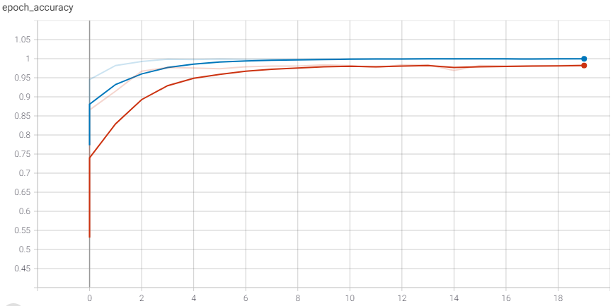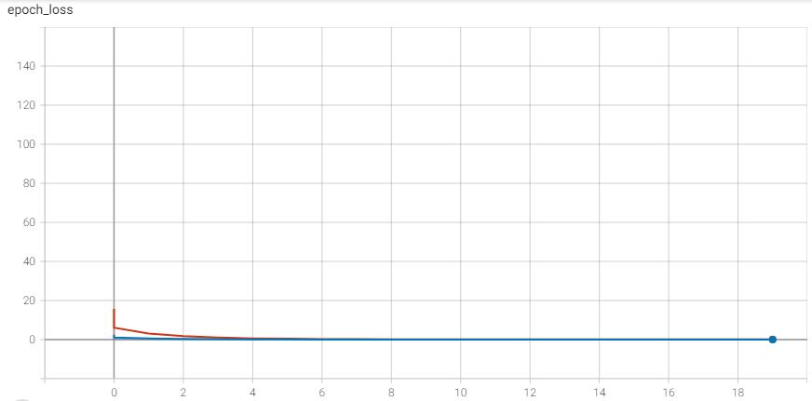

Fig. 4 (A): The accuracy curves Fig. 4 (B): The loss curves

**Conclusion**

CNN is one of the main categories to do the image recognition and image classifications, which is used to achieve good accuracy in image classification which avoids preprocessing and it can learn complex features automatically from images depending on its multilayer perceptron’s. This paper's based on CNN model for brain tumor classification, were the main contributions are multifold, as there is a large number of researches using the convolutional neural network to classify brain tumors, but it is not mostly based on classifying the normal brain with it , our model CNN takes MRI Brain image, processes it, and categorizes it into one of three classes infected with low glioma, high glioma and normal brain through many experiments in modifying the hyperparameter to reach results of high accuracy of the model without the need to use a large number of images, unlike most researches, Where the accuracy of our model reached 98.36% in test set recognition rates, this is a high percentage that we think will help clinicians in classifying brain tumors. In this model four hidden layers were used, selecting Relu as the activation function, Adam and SGD were used as optimizers used to train the network, to improve the deep learning network’s ability to classify with high accuracy. Several methods used to improve network performance, including the implementation of the Batch Normalization and dropout methods, the best results of our model reached when using the (SGD)optimizer with the Batch Normalization technique where the accuracy increases at a high rate (98.36٪) also decreases the rate of overfitting on training data.

**Reference**

1. WHO. Cancer [Internet]. [cited 2020 Dec 11]. Available from: https://www.who.int/health-topics/cancer#tab=tab_1

2. Plummer M, de Martel C, Vignat J, Ferlay J, Bray F, Franceschi S. Global burden of cancers attributable to infections in 2012: a synthetic analysis. Lancet Glob Heal. 2016 Sep 1;4(9):e609–16.

3. Goodenberger ML, Jenkins RB. Genetics of adult glioma. Vol. 205, Cancer Genetics. 2012. p. 613–21.

4. Mamelak AN, Jacoby DB. Targeted delivery of antitumoral therapy to glioma and other malignancies with synthetic chlorotoxin (TM-601). Expert Opin Drug Deliv. 2007 Mar;4(2):175–86.

5. Center C. Types of Brain Cancer: Common, Rare and More Varieties | CTCA [Internet]. [cited 2020 Dec 11]. Available from: https://www.cancercenter.com/cancer-types/brain-cancer/types

6. Godenschweger F, Kägebein U, Stucht D, Yarach U, Sciarra A, Yakupov R, et al. Motion correction in MRI of the brain [Internet]. Vol. 61, Physics in Medicine and Biology. Institute of Physics Publishing; 2016 [cited 2021 Jan 12]. p. R32–56. Available from: /pmc/articles/PMC4930872/?report=abstract

7. Afshar P, Plataniotis KN, Mohammadi A. CAPSULE NETWORKS ’ INTERPRETABILITY FOR BRAIN TUMOR CLASSIFICATION VIA RADIOMICS ANALYSES Concordia Institute for Information Systems Engineering , Concordia University , Montreal , QC , Canada Department of Electrical and Computer Engineering , Universit. 2019 IEEE Int Conf Image Process. 2019;3816–20.

8. Alqudah AM, Alquraan H, Qasmieh IA, Alqudah A, Al-Sharu W. Brain tumor classification using deep learning technique - A comparison between cropped, uncropped, and segmented lesion images with different sizes. Int J Adv Trends Comput Sci Eng. 2019;8(6):3684–91.

9. Badža MM, Barjaktarović MC. Classification of brain tumors from mri images using a convolutional neural network. Appl Sci. 2020;10(6).

10. BraTS Challenge · GitHub [Internet]. [cited 2021 Jan 13]. Available from: https://github.com/BraTS

11. Khan MA, Ashraf I, Alhaisoni M, Damaševičius R, Scherer R, Rehman A, et al. Multimodal brain tumor classification using deep learning and robust feature selection: A machine learning application for radiologists. Diagnostics. 2020;10(8):1–19.

12. Mzoughi H, Njeh I, Wali A, Slima M Ben, BenHamida A, Mhiri C, et al. Deep Multi-Scale 3D Convolutional Neural Network (CNN) for MRI Gliomas Brain Tumor Classification. J Digit Imaging [Internet]. 2020 Aug 1 [cited 2021 Jan 16];33(4):903–15. Available from: https://link.springer.com/article/10.1007/s10278-020-00347-9

13. Wu W, Li D, Du J, Gao X, Gu W, Zhao F, et al. An Intelligent Diagnosis Method of Brain MRI Tumor Segmentation Using Deep Convolutional Neural Network and SVM Algorithm. Comput Math Methods Med. 2020;2020.

14. Seetha J, Raja SS. Brain tumor classification using Convolutional Neural Networks. Biomed Pharmacol J. 2018 Sep 1;11(3):1457–61.

15. Mohsen H, El-Dahshan E-SA, El-Horbaty E-SM, Salem A-BM. Classification using deep learning neural networks for brain tumors. Futur Comput Informatics J. 2018 Jun 1;3(1):68–71.

16. Farhi L, Zia R, Ali ZA. 5 Performance Analysis of Machine Learning Classifiers for Brain Tumor MR Images [Internet]. Vol. 8, Sir Syed University Research Journal of Engineering & Technology. 2018 Dec [cited 2021 Jan 15]. Available from: http://www.sirsyeduniversity.edu.pk/ssurj/rj/index.php/ssurj/article/view/36